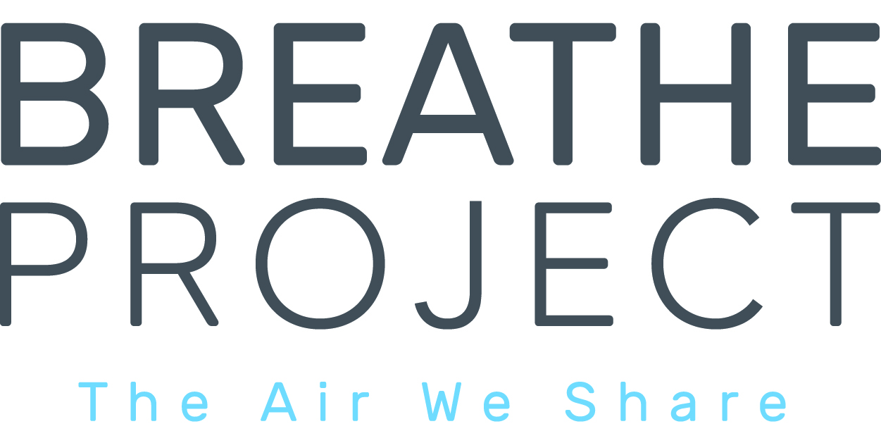

**FOR IMMEDIATE RELEASE**

Feb. 18, 2025

Contact: Debra Smit, Breathe Project

[dsmit@breatheproject.org](mailto:dsmit@breatheproject.org), 412-760-7677

***Single-Use Planet* Exposes the Dangers of Our Disposable Culture and Sheds Light on the Plastic Plant Operation in Beaver County and Its Impact on the Global Crisis of Plastic Pollution**

*The film features seven SWPA leading environmental advocates and green chemistry pioneer Terrence Collins*

**Pittsburgh, Pa. Feb. 20, 2025 –**Habitat Media will premiere its powerful new documentary, *Single-Use Planet,*in Pittsburgh this Thursday, a film that takes an in-depth look at the damaging impact of single-use plastics and the role the Petrochemical Plastic Plant in Monaca, Pa. plays in the global plastic pollution problem.

**Media is invited to attend**

Thursday, Feb. 20, 2025, Doors Open 6:15 p.m.

[Harris Theatre, 809 Liberty Ave. Sold Out!](https://www.eventbrite.com/e/single-use-planet-documentary-premieres-in-pittsburgh-on-feb-20-2025-tickets-1143178781509?aff=oddtdtcreator)

*(A Live Stream of the panel discussion will be available on the*[*Breathe Project YouTube page*](https://www.youtube.com/@BreatheProject)*from approximately 8:05pm - 9:30pm.)*

Speakers and panelists appearing on stage after the showing will include **Steve Cowan, Habitat Media,**Producer and Director, **Terrie Baumgardner,**Beaver County resident and Beaver County Marcellus Awareness Community (BCMAC), **Dr. Terrence Collins,** Green Chemistry Pioneer, Carnegie Mellon University (CMU), **Dr. Ned Ketyer,**president of Physicians for Social Responsibility Pa. and **Larry Schweiger,**author of  “Climate Crisis & Corrupt Politics and former President/CEO of National Wildlife Federation & PennFuture.

"*Single use Planet* is an epic film for Pennsylvanians,” said Terrence Collins of Carnegie Mellon University. “On the one hand, it identifies and dissects local human error in the plastics domain that is propelling our state deeper into chemically induced self-destruction. On the other, it spotlights courageous and brilliant Pennsylvanians who are leading us away from the abyss toward a safe and sustainable future. The film delivers a powerful lesson for the entire world.”

Can this powerful industry be persuaded to temper its production of single-use plastic? The search for answers leads from Southwestern Pennsylvania to Washington D.C. and around the globe.

As plastic consumption continues to rise worldwide, *Single-Use Planet* offers an urgent call to action, showing how this crisis is accelerating the destruction of ecosystems, contributing to the suffocation of marine life and threatening biodiversity. Through stunning visuals, expert interviews and the stories of people living in communities struggling with the consequences of plastic waste, the documentary paints a stark picture of a world grappling with the long-term ramifications of unchecked plastic production.

“The film documents how the gas industry bought enough Pennsylvania legislators to yield $1.6 billion in taxpayer subsidies to Shell, a foreign corporation, for a plastic cracker plant, thereby privatizing profits while socializing liabilities,” said Larry Schweiger.

“The U.S. Supreme Court distorted the Constitution in Citizens United v. Federal Election Commission by redefining ‘corporations’ as ‘people’ and equating ‘money’ with ‘free speech,’ distorting elections and skewing them in favor of monied interests, ranging from the fracking industry with its plastic production to Musk.”

The Habitat Media documentary will air on PBS stations nationwide in April.

The film is presented by Breathe Project in collaboration with the Beaver County Marcellus Awareness Community (BCMAC), Physicians for Social Responsibility of Pa. (PSRPA), Three Rivers Waterkeeper, PennFuture, Moms Clean Air and ProtectPT.

##